Selenium

**Day 3**

**Task 01: Create and Replay**

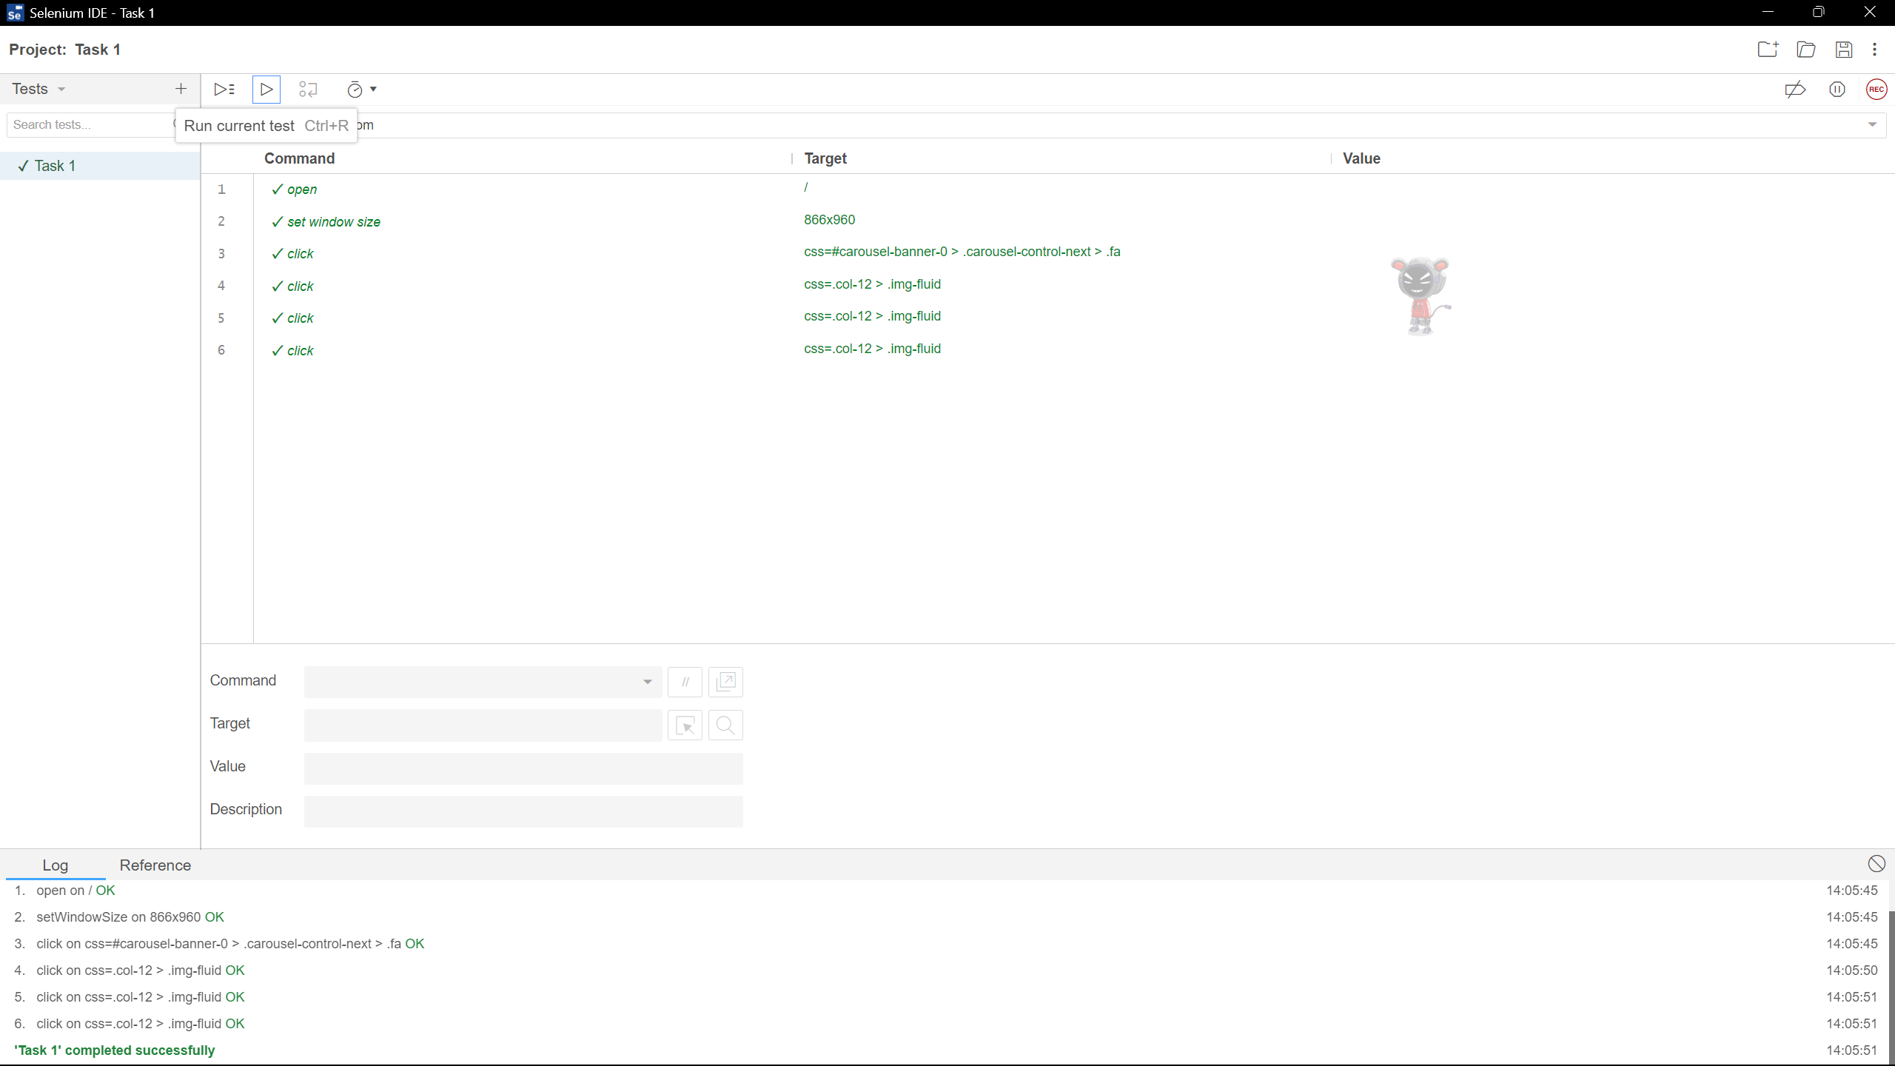

**Output:**

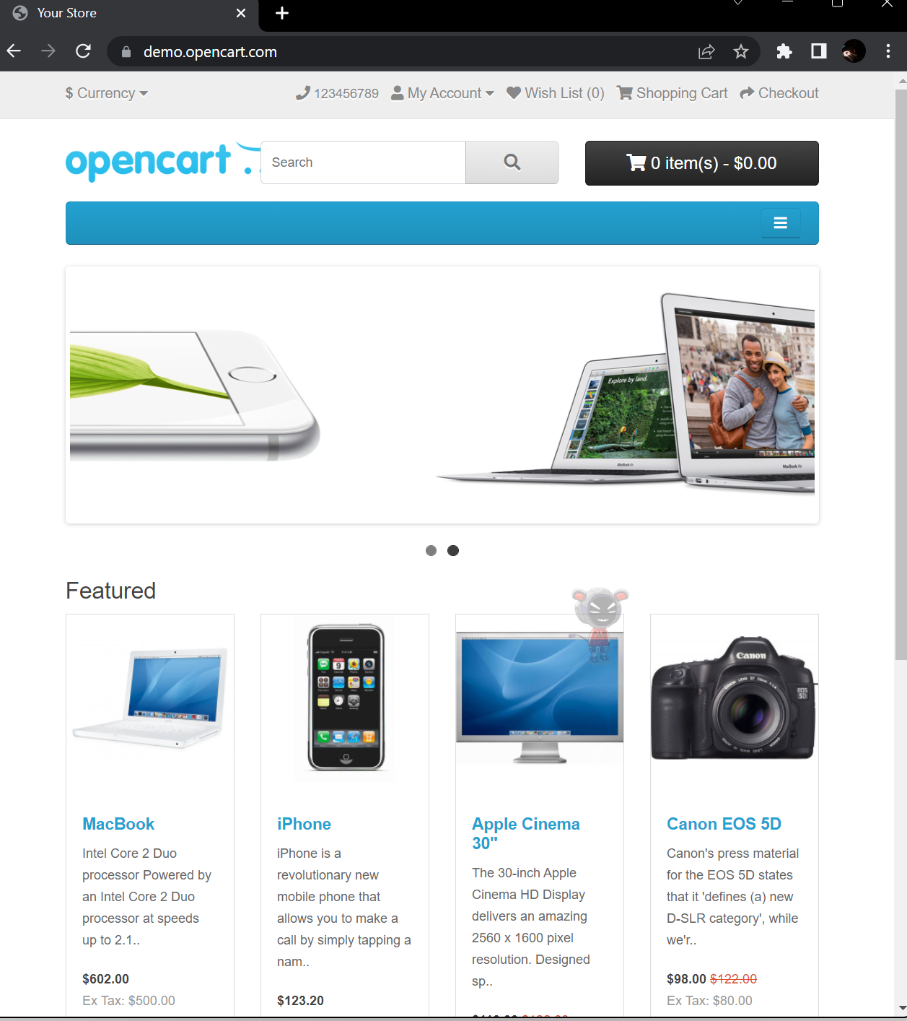

**Task 02: Selenese Commands:**

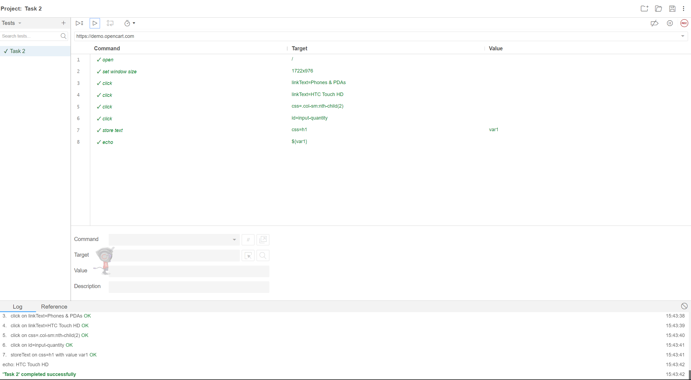

**Output:**

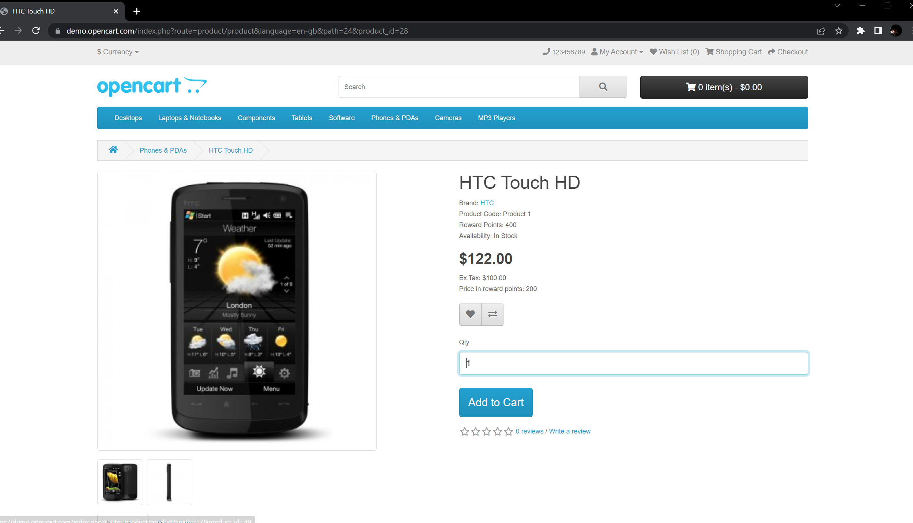

**Task 03: Selenese Commands:**

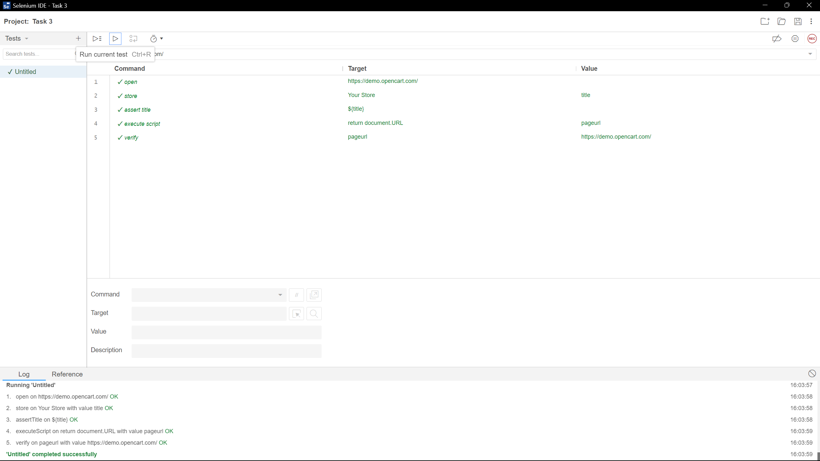

**Output:**



**Task 04: Selenese Commands:**

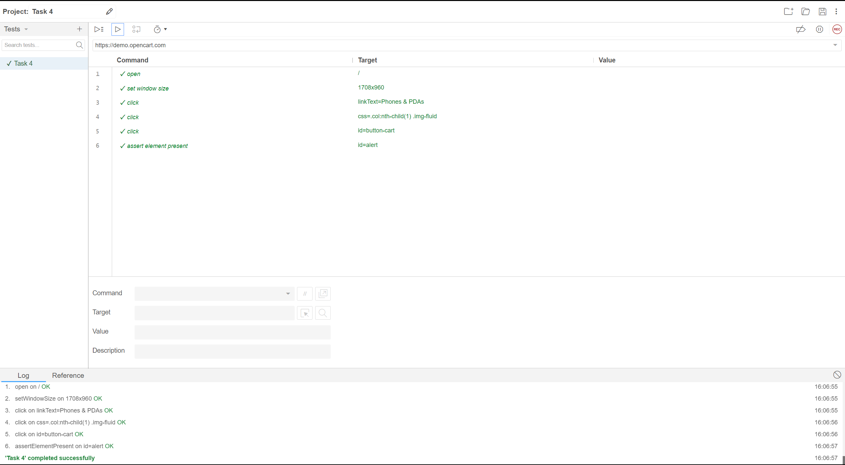

**Output:**



**Task 05: Selenese Commands:**

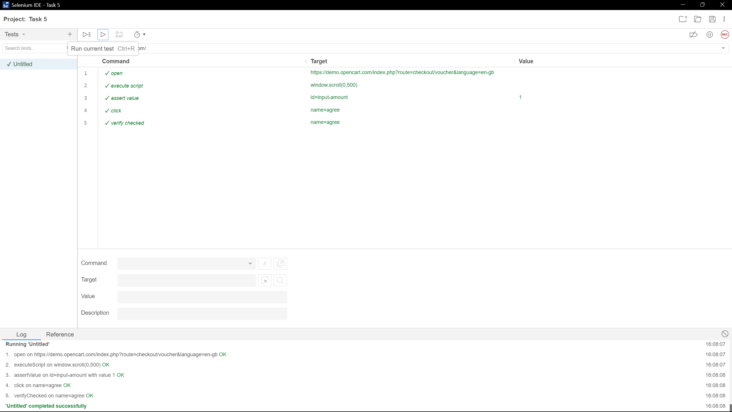

**Output:**

